Two Primary-Standard Deadweight Machines for the U.S. Air Force
A case study in primary-standards procurement, NIST mass traceability, and 0.001 % machine uncertainty
The Air Force Metrology and Calibration Program (AFMETCAL) is the central force-measurement reference for the U.S. Air Force, U.S. Space Force, and joint-service customers. Its primary-standard deadweight machines anchor the calibration chain through which the entire downstream Air Force force-measurement workload is traced from engine-thrust test stands at the major propulsion test facilities to airframe structural-test load cells across the inventory. By the early 2020s, AFMETCAL’s existing primary-standard calibrator, a deadweight machine that had been in service since the BRAC era, was approaching the end of its useful life, and the 0.003 % full-scale uncertainty it delivered no longer matched the requirements of modern propulsion and structural-test programs. AFMETCAL set out to replace it.
Working with Shane Popson, AFMETCAL Mechanical Engineer, and the AFMETCAL Mechanical Engineering team, Morehouse hosted multiple AFMETCAL site visits at our York, PA facility before the bid was issued. Together with metrology engineers, sales engineering, and laboratory staff at Morehouse, the application was evaluated against the following constraints:
- The replacement primary standard had to span the full Air Force force-calibration workload, from small-force aircraft loadcell calibration up to engine-thrust-class loads. For reference, the engines on a Boeing 787 produce on the order of 245 kN to 335 kN (55 000 lbf to 75 000 lbf) of thrust per engine.
- Combined machine uncertainty had to be improved by approximately one order of magnitude over the BRAC-era machine to better than 0.001 % of applied force — to be useful for the next 20 years – 30 years of program work.
- Mass traceability had to be established at the limit of US national capability, requiring direct partnership with the National Institute of Standards and Technology (NIST).
- The successful bidder had to deliver machine design, mass procurement coordination, on-site installation, and acceptance-test support as a single integrated package. Splitting these between vendors was not viable for a primary-standards facility.
Morehouse won the bid against the competing field, was less expensive by a large margin, and the two machines were dedicated as the AFMETCAL Founders Force Laboratory in Heath, OH, on September 12, 2024. AFMETCAL Mechanical Engineer Shane Popson, who led the project on the Air Force side, has publicly described the installation as the long-planned replacement of the BRAC-era primary standard and the capability AFMETCAL will operate for the next two to three decades. The Founders Force Laboratory is now the apex of the U.S. Air Force, U.S. Space Force, and joint-service force-measurement traceability chain.
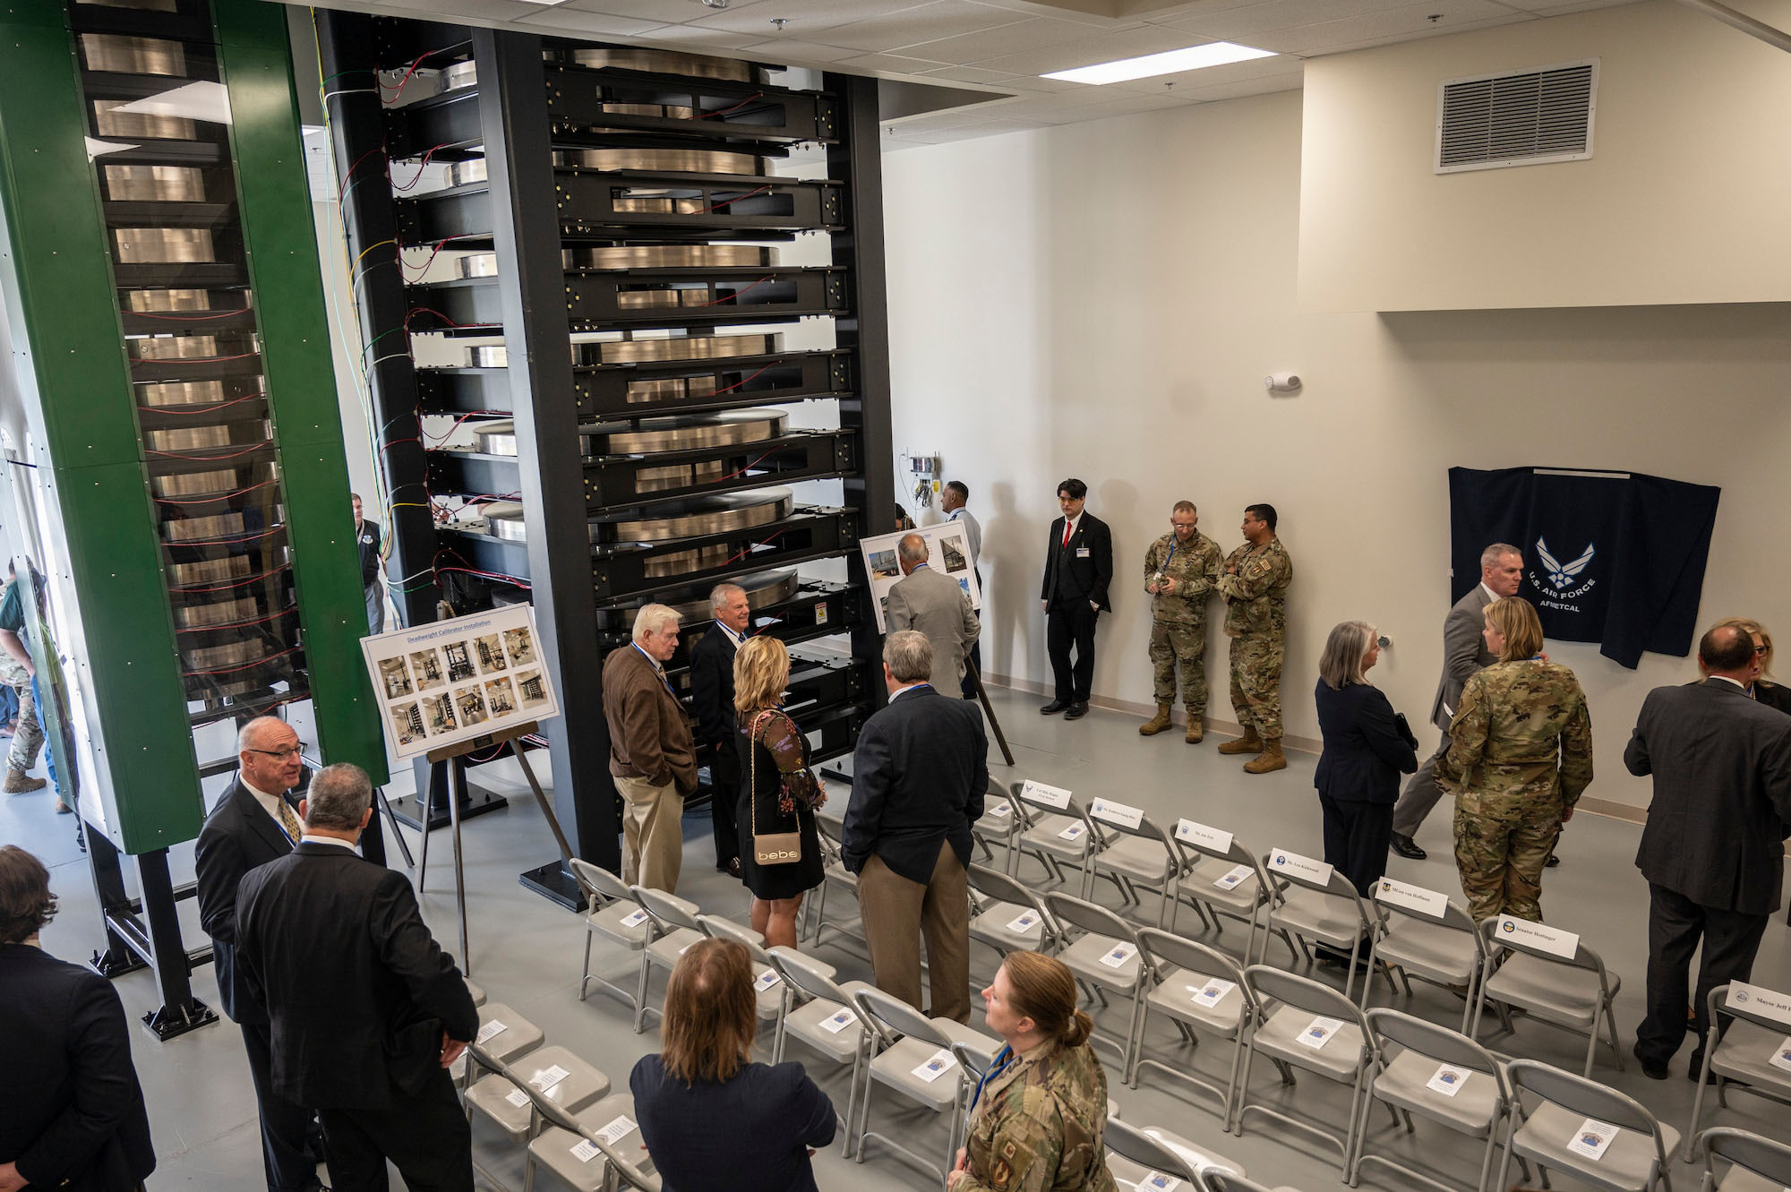
AFMETCAL Founders Force Laboratory dedication, September 12, 2024, Heath, OH. The 453.7 kN (102 000 lbf) primary-standard deadweight machine is visible at left; the 133.4 kN (30 000 lbf) machine sits to its right. Credit: U.S. Air Force AFMETCAL.
The body of evidence developed across the project decomposes into three deliverables.
Deliverable 1: A two-machine architecture spanning the full AFMETCAL workload
The replacement was specified as two coordinated primary-standard deadweight machines: 453.7 kN (102 000 lbf) and 133.4 kN (30 000 lbf). The two-machine architecture was deliberate. A single 453.7 kN machine would have covered the full force range nominally, but at the low end of its scale, the resolution and percent-of-applied-force uncertainty performance would have been inadequate for small-force aircraft load cell calibration. The 133.4 kN machine provides the lower-force coverage required by AFMETCAL for that workload. Together the two machines cover the full operating range of Air Force primary-standard force calibration with consistent percent-of-applied-force uncertainty across the range.
Deliverable 2: Mass traceability through a NIST primary-standard partnership
Each machine derives its applied force from a stack of large metal masses calibrated by NIST. NIST calibrated several dozen large metal masses for the project, with a target uncertainty on the order of 0.0010 %. To meet that target, masses falling slightly below tolerance were brought back into specification by adding small adjustment masses into built-in cavities, sealing the cavities, and re-calibrating. The result is a mass set whose individual uncertainties are within the narrow window required for the machines to deliver their specified combined uncertainty.
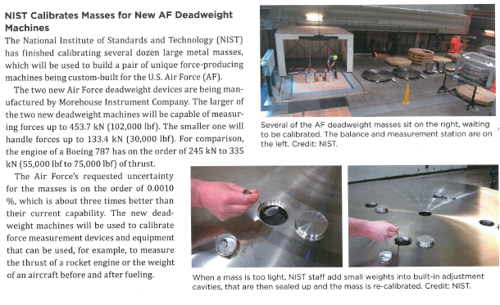
NIST staff calibrate one of the deadweight masses for the AFMETCAL Founders Force Laboratory. Where a mass fell out of tolerance, small adjustment weights were added into a built-in cavity, the cavity was sealed, and the mass was re-calibrated. Source: NIST Office of Weights and Measures.
Deliverable 3: Combined machine uncertainty of 0.001 % using the USAF algorithm
With the NIST-calibrated mass stack, the published USAF uncertainty algorithm, and the Morehouse primary-standard deadweight design, the two machines achieved a combined measurement uncertainty of 0.001 % of applied force at acceptance. This is approximately 3 × better than the prior BRAC-era machine’s 0.003 % and meets the program target for the next 20 years – 30 years of AFMETCAL workload. The Founders Force Laboratory is now the lowest-uncertainty primary-standard force facility in the U.S. Department of Defense.
The Morehouse Impact
Three points stand out from the project.
- The procurement was won on price as well as on technical merit. AFMETCAL’s published account states the win came in at a large margin less expensive than the competing field. Primary-standards procurement is normally awarded on technical capability with price as a secondary factor; in this case, Morehouse delivered the highest combined uncertainty performance in the field at the most competitive price.
- Installed hardware, not market positioning. Several competitors describe themselves as leading suppliers to the US military without a comparable single-installation prestige reference. AFMETCAL chose Morehouse to design, build, and install the actual primary-standard machines now in service at Heath, OH.
- The Founders Force Laboratory is now the apex US reference for force calibration in the propulsion and structural-test segments served by the Air Force. Test stands at the major propulsion test facilities, airframe structural-test load cells, and the rest of the downstream Air Force calibration workload are all traceable, ultimately, through the two Morehouse machines installed at Heath, OH.
Safety and design considerations
Primary-standard deadweight machines impose engineering and operational constraints that go beyond ordinary force calibration. Customers planning a similar primary-standards installation should account for the following:
- Building structural design. A deadweight machine transmits its full applied force directly into the building structure. Floor loading, footing design, and column strength must be specified by a structural engineer before the machine is shipped.
- Mass handling. Each large mass weighs hundreds of pounds, and the masses are lifted into the machine repeatedly during operation. The lab requires a properly rated overhead handling system, lifting fixtures, and operator training to avoid both injury and damage to the calibrated masses.
- Environmental control. Mass-derived force is sensitive to local gravity, air density, and temperature. The lab must be environmentally conditioned to a tight tolerance, and the local gravity value must be measured and applied; taking the standard 9.806 65 m/s² is not adequate for primary-standard work at this uncertainty level.
- Operator certification. Primary-standard calibration is unforgiving to procedural error. Operators must be certified on the specific machine and procedure, and the procedure itself must be controlled under the lab’s quality system.
- Automation and software. The Morehouse Deadweight Calibration System (DCS) handles ISO 376 §7.4.3 timing, weight application, and USB load-cell capture, eliminating the operator-induced variability that dominates at this uncertainty level. Free spreadsheet tools cover CMC budgets, expanded-uncertainty-per-point, ASTM E74 Method B, and TUR / measurement-risk analysis for the surrounding ISO/IEC 17025 workflow.
Force Calibration Solutions by Morehouse
Primary-standards procurement is difficult, but Morehouse is here to help. We welcome the opportunity to review your application, scope the machine design, coordinate mass procurement with NIST or your national metrology institute, and deliver a primary-standard installation that gives you a defensible measurement reference for the next 20 years – 30 years. Contact us at (717) 843-0081 or sales@mhforce.com for a consultation.
Further reading
The 20 years – 30 years recalibration interval rests on decades of NIST and NPL mass-stability evidence and the lessons from NIST’s 2014–2016 teardown of the world’s largest deadweight machine. Henry Zumbrun synthesizes that evidence and the underlying ISO/IEC 17025 / ILAC G24 compliance picture in Deadweight Primary Standards: Best Practices and Their Associated Risks for Stability Determination in Compliance with ISO/IEC 17025, Cal Lab: The International Journal of Metrology, Apr–Jun 2025.
ISO/IEC 17025 / ANSI/NCSLI Z540.3 Accredited · NVLAP Lab Code 600259 · A2LA Cert. 1398.01 · The Force in Calibration Since 1925

